Phylogenetic and Structural Analysis of PPE18 (Rv1196) across Mycobacterium tuberculosis Lineages
Aaradhya Aggarwal Independent Computational Analysis
aaradhya.aggarwal2701@gmail.com
1. Introduction
The PE and PPE multigene families are unique to mycobacteria and account for nearly 10% of the coding capacity of the Mycobacterium tuberculosis H37Rv genome. These genes encode proteins involved in host–pathogen interactions, immune modulation and antigenic variation. Due to their repetitive nature and high GC content, PE/PPE genes have historically been difficult to resolve using short-read sequencing technologies.
Recent long-read sequencing studies have demonstrated that gene conversion and structural variation within the PE/PPE families contribute substantially to genetic diversity, even among closely related outbreak strains. A 2025 study from the Gagneux laboratory showed that gene conversion events involving ppe18 and ppe57 can introduce multiple variants simultaneously and account for a significant proportion of observed variation (Stritt et al., 2025).
PPE18 (Rv1196, also known as Mtb39A) is of particular interest because it is a major component of the M72/AS01E vaccine candidate. Previous work has shown that sequence variation in ppe18 can affect predicted T-cell epitopes (Homolka et al., 2016). The present study therefore examines the phylogenetic conservation and structural features of PPE18 across publicly available strains.
2. Methods
- Complete genomes of Mycobacterium tuberculosis belonging to Lineages 1, 2, 3 and 4 were downloaded from the Bacterial and Viral Bioinformatics Resource Center (BV-BRC).
- The reference protein sequence of PPE18 (Rv1196) was retrieved from Mycobrowser.
- This sequence was used as query in NCBI BLASTP (restricted to Mycobacterium tuberculosis, taxid 1773) to extract corresponding PPE18 sequences from public databases.
- Sequences showing ≥99% identity and 100% query coverage were retained (final dataset: 15–18 sequences).
- Multiple sequence alignment was performed using Clustal Omega with default parameters.
- A distance-based phylogenetic tree was constructed using the Simple Phylogeny tool (EMBL-EBI).
- Three-dimensional structural modelling of H37Rv PPE18 was carried out using the SWISS-MODEL homology modelling server.
- Model quality was assessed using Global Model Quality Estimate (GMQE), QMEAN scores, and Ramachandran plot analysis.
3. Results
Sequence Retrieval

Figure 1. Selection of M. tuberculosis genomes belonging to Lineages 1–4 from BV-BRC.
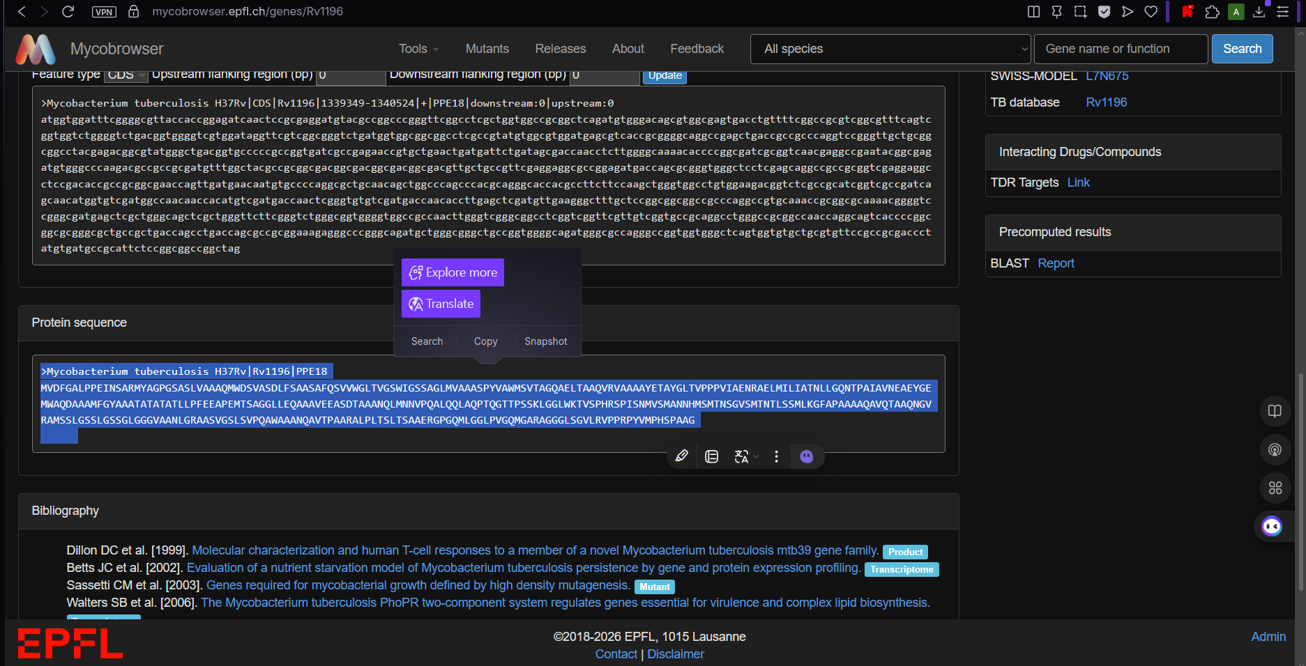
Figure 2. Reference PPE18 (Rv1196) gene and protein information retrieved from Mycobrowser.

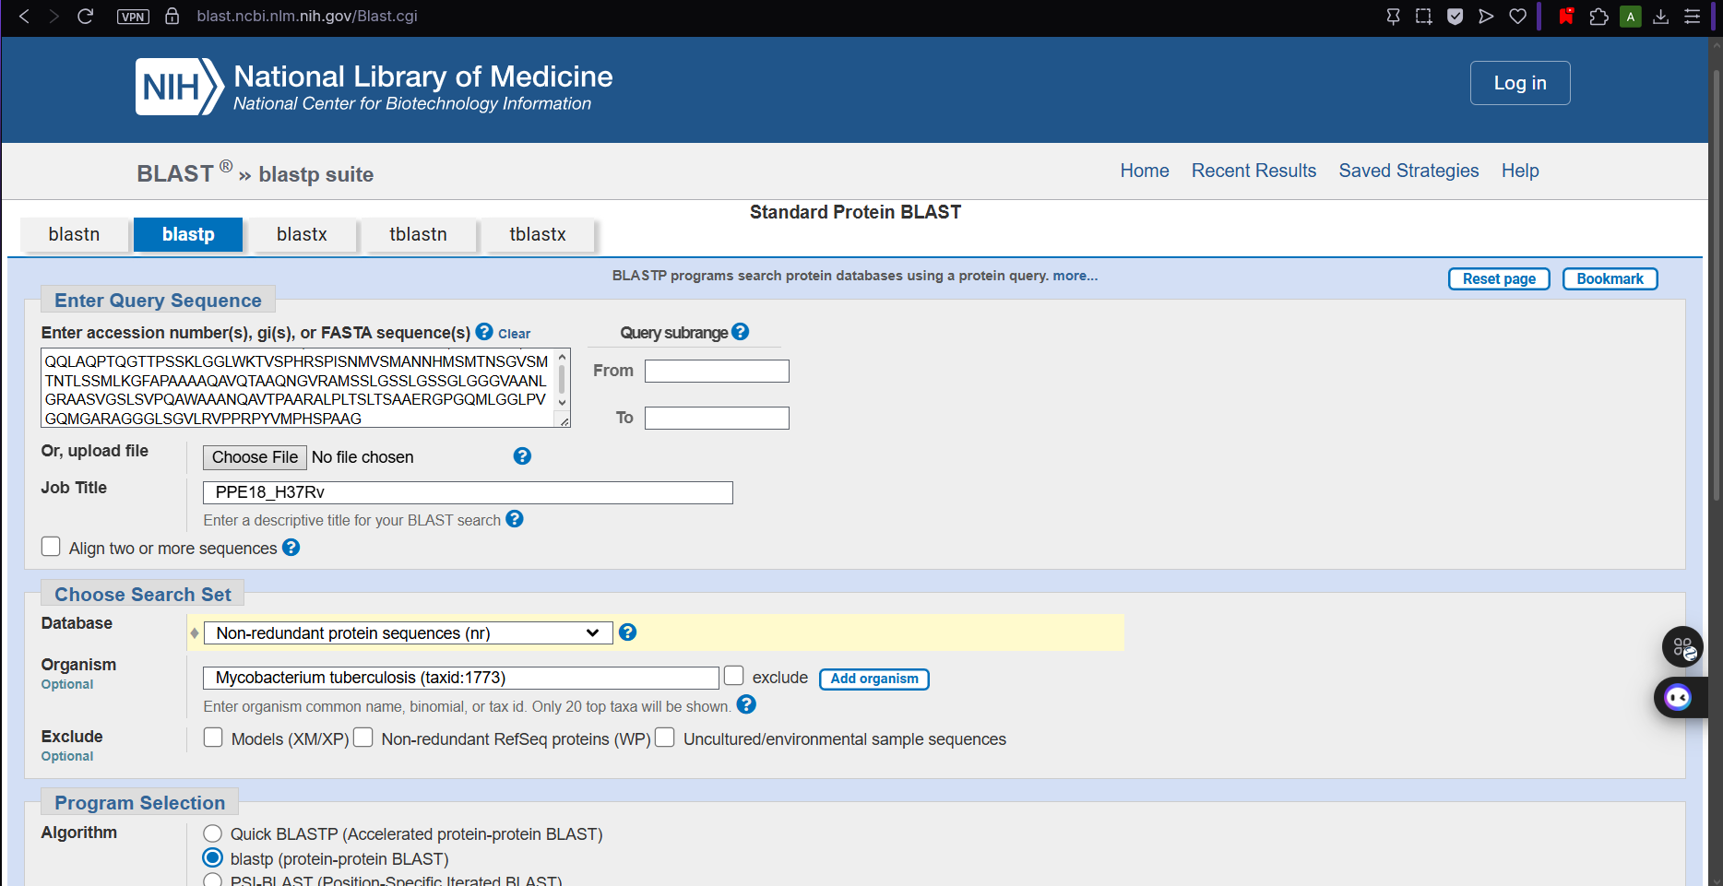
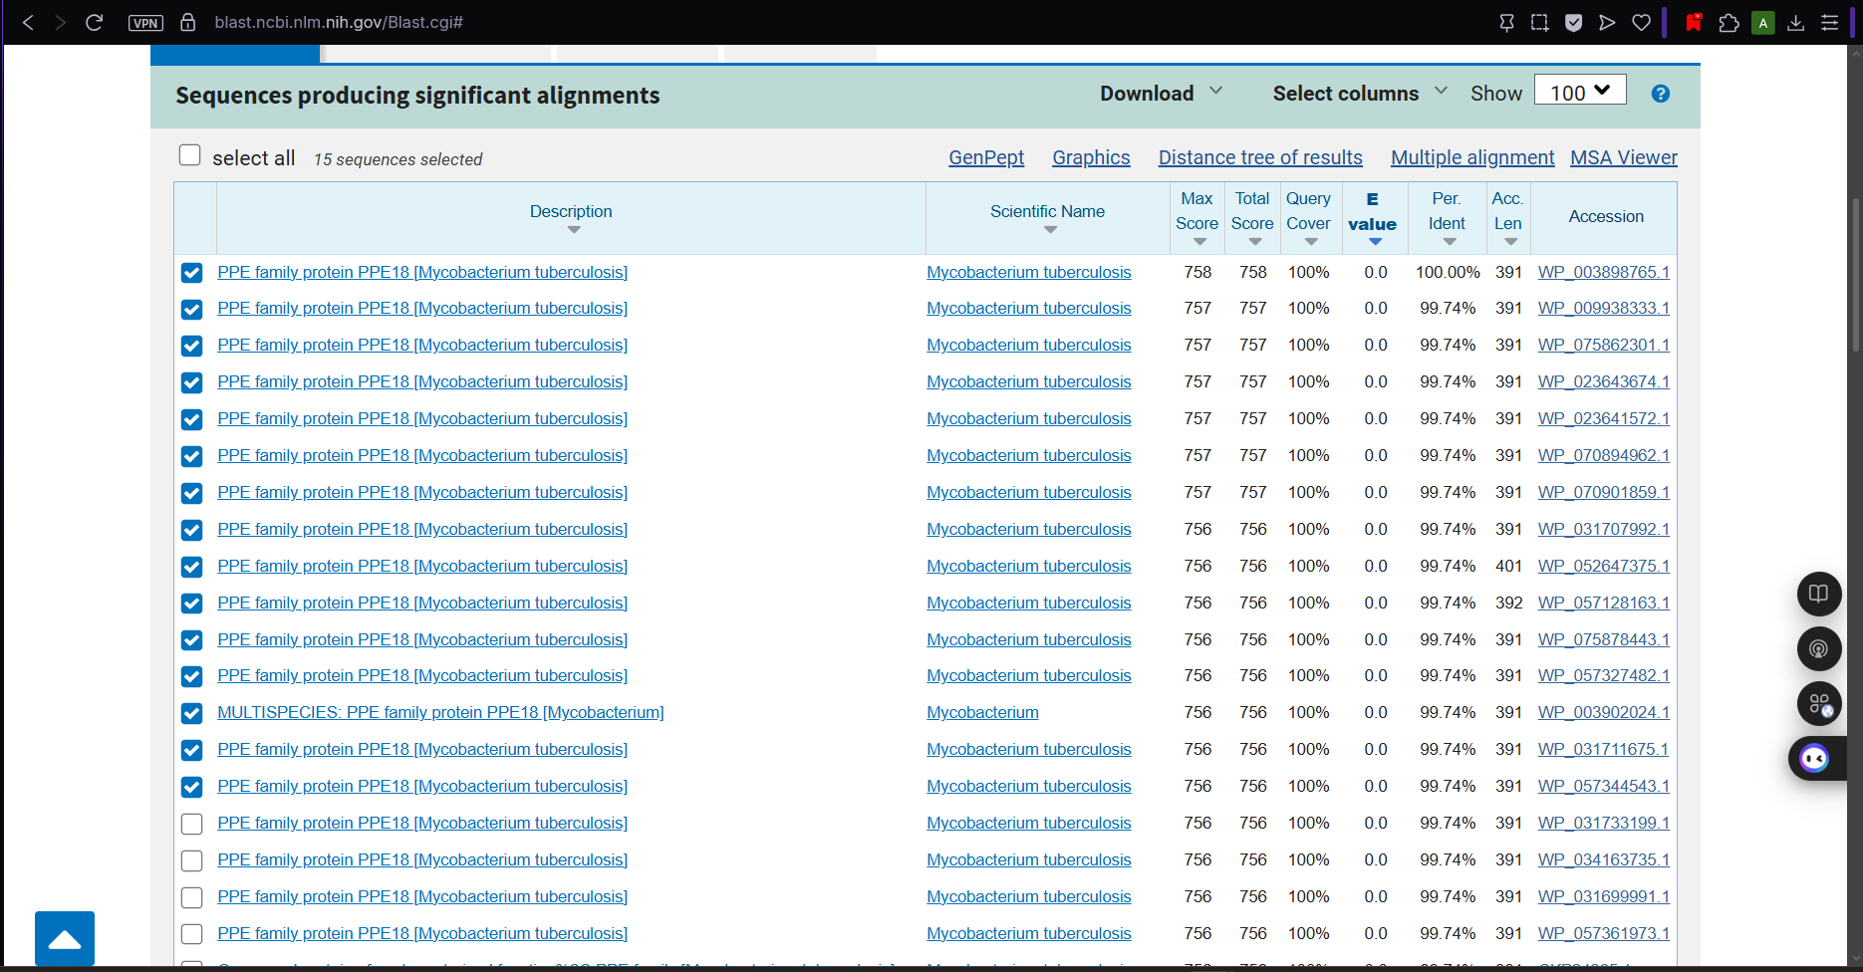
Figure 3. NCBI BLASTP results showing high-identity PPE18 protein hits ( ≥99% identity, 100% query coverage).
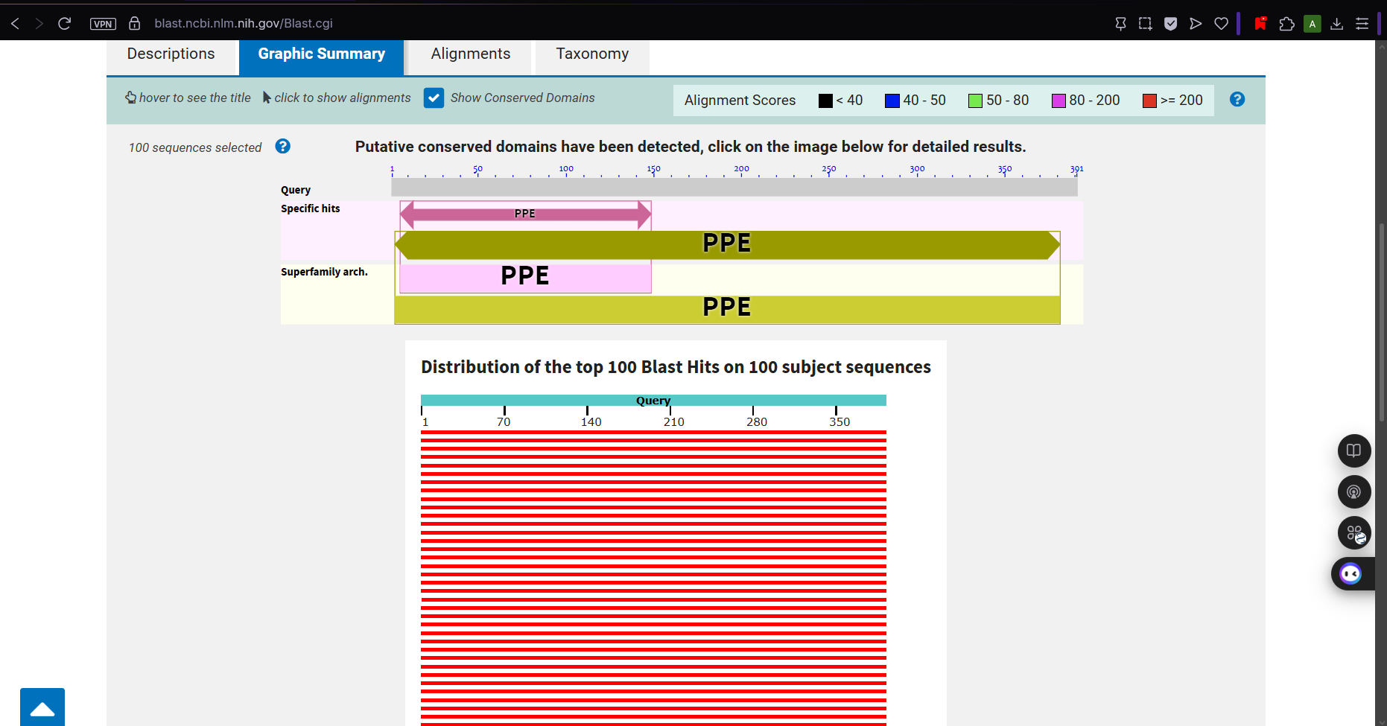
Figure 4. Graphic summary of NCBI BLASTP results for PPE18. All top hits show full-length coverage and the characteristic PPE domain.
Multiple Sequence

Figure 5. Multiple sequence alignment of PPE18 sequences generated using Clustal Omega.
Phylogenetic Analysis
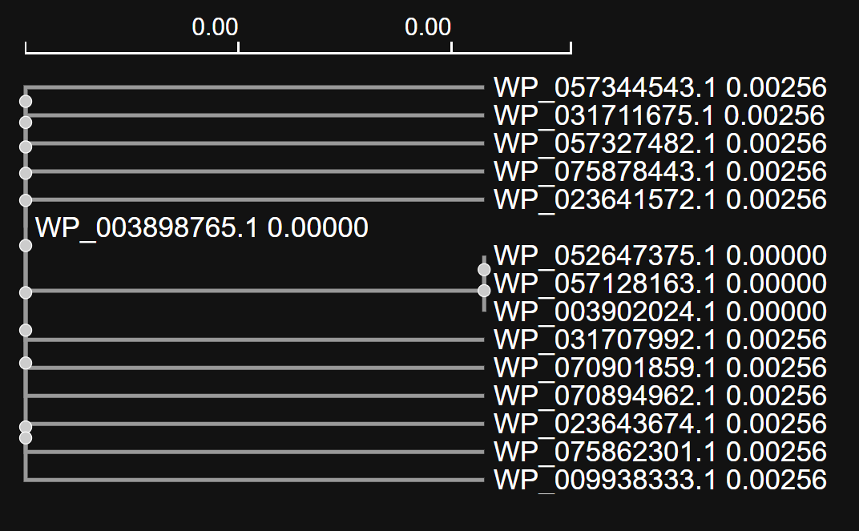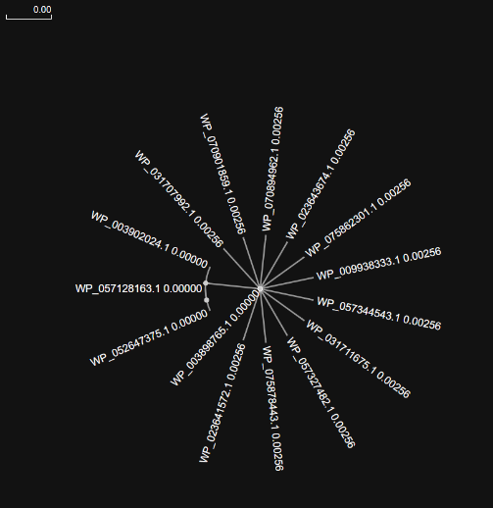
Figure 6. Distance-based phylogenetic tree of PPE18 sequences. Most sequences showed genetic distances of 0.00000, with a maximum observed distance of 0.00256. No clear lineage-specific clustering was observed.
Structural Modelling
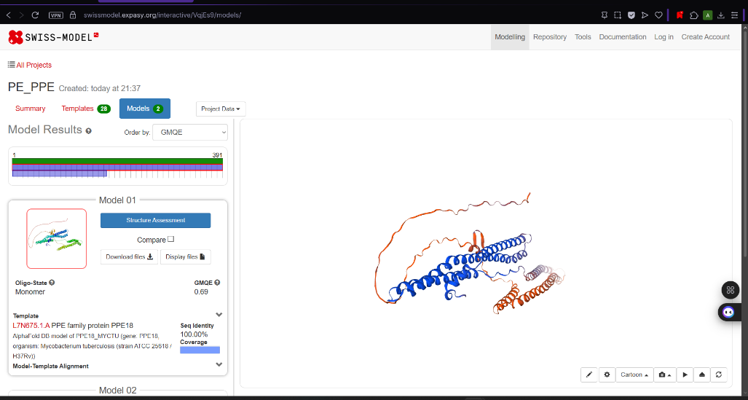
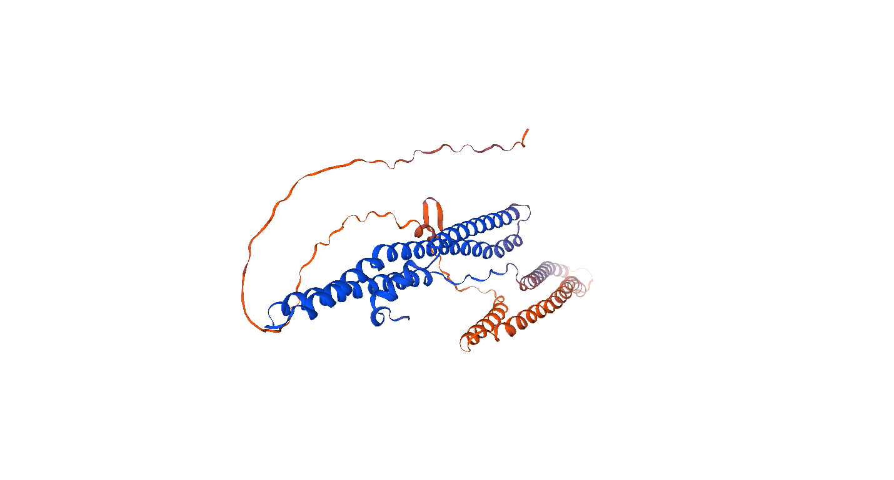
Figure 7. Predicted three-dimensional structure of PPE18 (H37Rv) generated by SWISS-MODEL.
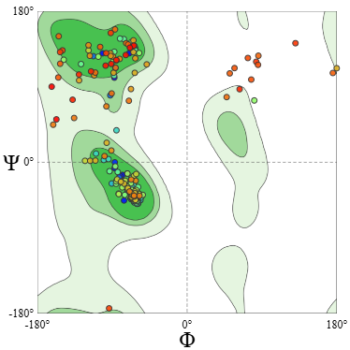
Figure 8. Ramachandran plot of the PPE18 model. The majority of residues fall within favoured regions, indicating acceptable overall model quality
4. Discussion
The high degree of sequence conservation observed in PPE18 is consistent with purifying selection acting on this antigen. This finding is relevant for the M72/AS01E vaccine candidate, as many of the targeted epitopes appear relatively stable across the strains examined in this study.
However, the limited diversity also highlights an important limitation of the current dataset. Many publicly available sequences are nearly identical, and short-read data frequently miss structural variants and gene conversion events. Recent long-read work from the Gagneux laboratory has shown that gene conversion involving ppe18 and related genes can generate multiple changes simultaneously (Stritt et al., 2025).
Future direction: Expanding this analysis to complete long-read assemblies and additional PE/PPE family members (particularly ppe57 and selected pe_pgrs genes) would provide deeper evolutionary insight and align directly with ongoing research in the laboratory.
5. Conclusion
This focused computational analysis confirms the strong sequence conservation of PPE18 and provides a preliminary structural model supported by Ramachandran analysis. While diversity was limited in the present dataset, the workflow is clear, reproducible, and ready to be extended to more variable PE/PPE genes and long-read genomic data.
References
- Stritt, C., Reitsma, M., García-Marín, A. M., Goig, G., Dötsch, A., Borrell, S., Beisel, C., Comas, I., Brites, D., & Gagneux, S. (2025). Gene conversion and duplication contribute to genetic variation in an outbreak of Mycobacterium tuberculosis. Microbial Genomics, 11(5), 001396. https://doi.org/10.1099/mgen.0.001396
- Homolka, S., et al. (2016). High sequence variability of the ppe18 gene of clinical Mycobacterium tuberculosis complex strains potentially impacts effectivity of vaccine candidate M72/AS01E. PLoS ONE, 11(3), e0152200.
- Cole, S. T., et al. (1998). Deciphering the biology of Mycobacterium tuberculosis from the complete genome sequence. Nature, 393, 537–544.
- Gey van Pittius, N. C., et al. (2006). Evolution and expansion of the Mycobacterium tuberculosis PE and PPE multigene families. BMC Evolutionary Biology, 6, 95

